April 12th, 2012
Hi
I will try to complete this letter as quickly as possible as I am going to have a busy day shuttling stuff across to the flat. So far, I have made 32 such shuttles. It is surprising how little a Hong Kong supermarket trolley holds, necessitating many trips. US trolleys are much bigger, though of course, if full of books or other harny stuff, would be difficult to push. Here, I first take the trolley to the basement then have to push it up the exit to ground level, and that can be tough with heavy loads. Ikea come to deliver and install the furniture on Friday. Very efficient; it took them just 1 ½ hours to assemble everything; it would have taken me 1 ½ days or maybe longer! I liked the screw drivers they used. They were electric (battery and without long cables; others were connected to the mains for use if necessary) and when used, little lights would come on the illuminate the area being worked on. More to impress me about Ikea - the guys took off their shoes and worked in socks, used the wrapping material to protect the floor. cleaned up afterwards and removed all the rubbish. The reason for all the rush is so that I can move in at the end of this month instead of the end on May which is when my lease here actually ends. I asked the General Manager if I could finish the lease early and without penalty and even asked for a refund for the month!! He agreed. It probably helped that I spun the line - which is completely true - that by so doing, the hotel could use for room for daily visitors at the substantially increased rates they are now using.
Last Sunday, I had to go to Ikea again to change a small bookcase for a larger one; that can't be done by phone. On the way, at a railway station, I got reimbursed the $39.60 extra charge for the wrong Octopus card issued to Uncle Bruce (using a chit they had posted to me). Hardly worth it as it only covered the MTR fares he had taken (we had taken the card to the MRT railway station service centre). To get a refund for the excess bus fares would mean a trip to their offices, wherever they are; just not worth the trouble. On the same day, Australia!!! win the Tokyo sevens; their first victory for some time.
Mentioning Australia, there was a report on Aus TV of research with young children that soft drinks --> change in size of retinal blood vessels --> which is a good predictor of heart(?) disease later in life. And this is happening with chilren at a young age. The message is clear - keep kids off soft drinks. I think that some time in the future, firms such as Coca Cola are going to face the same kind of lawsuits that tobacco firms faced. They know the dangers of their products but advertise so extensively knowing that these ads are effective for most people (but not with me!!). I remember when I was a boy, we drank mainly nilk and in my case because I wanted to and not because I had to (though I loathed milk puddings to such an extent that my mother eventually gave up on them). And milk in those days was only full cream and was not homogenised. There was always a layer of oil on top of the milk which many people would decant off for other uses.
Last Wednesday was a holiday for the Ching Ming festival (spring grave sweeping). I did not hear of any hill fires as a result of careless grave sweepers; usually there are a large number. On the same day. 200 US Marines arrived in Darwin for a six-month deployment. This is the beginning of what will be quite a large Marines base there.
On Thursday, the Lantau cable car re-opend after a lay-off for over two months to fix mechanical problems. Then, would you believe it, after just a few hours of operation it had to shut down again for two hours because of a thunderstorm, which are not common at this time of the year.
The run yesterday was a bit tough: around the Tai Lam reservoir but in the 'reverse' direction, but at 2 h 15 min, was only 1 min slower than for same route last year. (It is not the run described in last year's letter below, but was the run that is in next week's letter). I may make this the last run of the season - it depends on how much work is still needed to move things over to the flat. Also, by then the Singapore publisher should have received the comments from the Education Department on the books which will mean a lot of work for a while. Somewhat annoying though. They were supposed to have returned the comments early in March which is why I was not able to come to Hawaii then.
In moving stuff, I came across a floor plan for the flats in Residence 12 at CUHK. It included some lenghts, so I calculated the area of 5B and it came to about 1800 square feet. Quite large. Much larger than the 440 square feet of the flat I am moving to. But, with its size and with a wooden floor, it took a long time to clean. The 'new' flat has all marble floors and it easy to clean; I think it will take less than 30 minutes. Also, a marble floor seems to keep the place cooler, though I will have to wait for the real summer heat to see if this is actually the case.
That's about it. Now to work!
Cheers

April 10th, 2011
Hi
Little to write about. Tuesday was a holiday, though I did not know at first what it was for. Turned out to be for the Ching Ming (spring grave-sweeping) festival. Of course, there were the usual hill fires due to people lighting fires carelessly near grave sites. I think there were only about 40, which is quite a lot fewer than at other times.
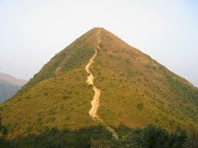
The run yesterday was quite exhausting. At about 22-23⁰C, it was not too hot but it was very humid. I went up Needle Hill in the Shing Mun reservoir area; I don't know if any of you have been up this hill but it is quite steep, hence its name. A 2 h 52 min, the run was longer than I had anticipated as the route was not exactly the same as for past runs. Very tired in afternoon.
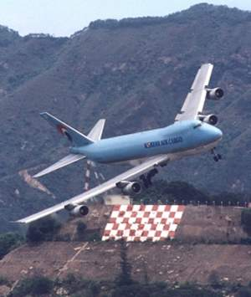
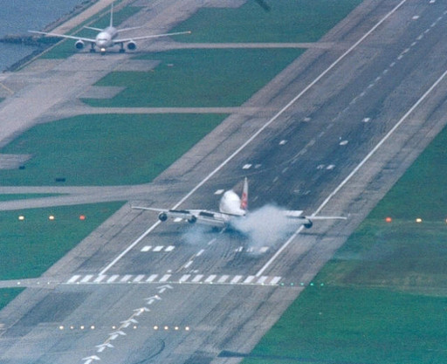
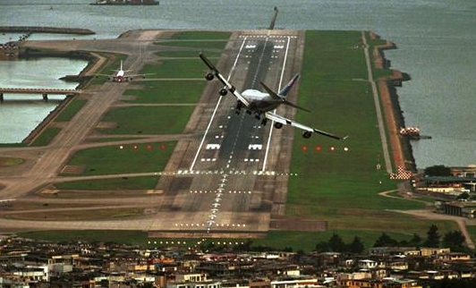
BTW, when I was searching for a picture of Needle Hill, I came across these pictures of planes landing at the old Kai Tak airport from the land approach where planes had to approach low over the buildings and then make a sharp 90⁰ turn with only a few hundred metres before touching down on the runway. Although an extremely dangerous approach, there were never any serious accidents though there were a few close calls. I actually enjoyed this landing as you could look out the window and see the people on the streets below. Can any of you remember landing using this approach? Have a look at these videos for interesting landings:
http://www.youtube.com/watch?v=OtnL4KYVtDE
From cockpit:
http://www.youtube.com/watch?v=lx3Ccs5tKfw
The old Kai Tak runway is being converted into a cruise ship terminal and will be ready in a couple of years.
From my comment last week about mainland mothers coming to HK to give birth. The government has now not making such appointments until the end of the year.
That’s about it for now. Not much this time.
Cheers

